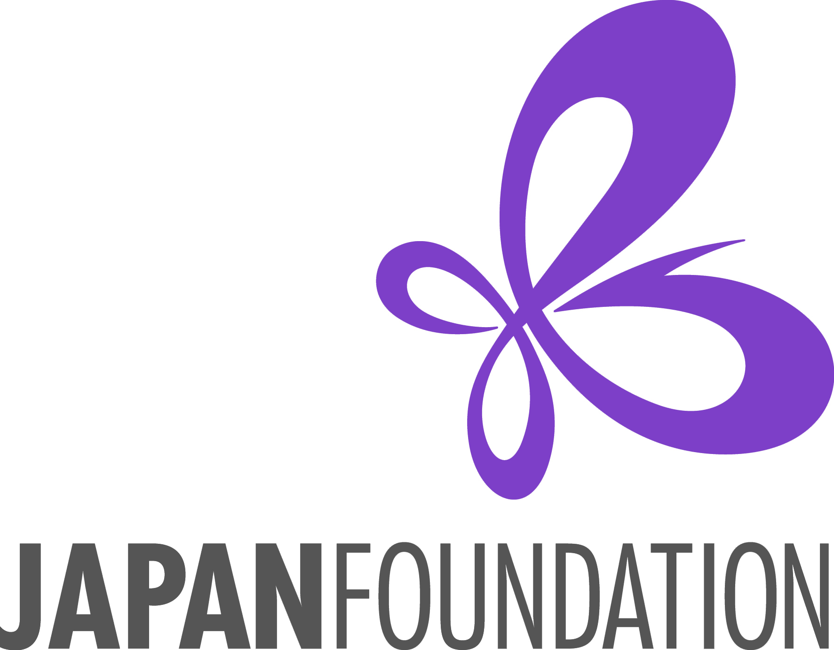

Fiscal Year 2025-26

## Japanese Teaching Materials Purchase Grant

**Application Instructions**

**Program Description**

The Japan Foundation, Los Angeles (hereafter “JFLA”) provides this program to assist U.S. educational institutions to purchase teaching materials (textbooks, audio-visual materials, e-learning software, dictionaries, teachers’ reference books, etc.) for their Japanese-language courses by providing financial support of up to **$1,000**.

**Conditions of Grant**

1. Applicants should notify JFLA in advance of their intent to apply for the grant. Next, the applicant must submit an application form containing their **wish list**. On the wish list, indicate titles, unit prices, quantities, and the estimated total cost of the materials (including tax and shipping & handling charges). Applicants who are awarded this grant (hereafter referred to as “grantees”) will be responsible for purchasing the materials on their own. The total estimate of the wish list may be over $1,000, but the Japan Foundation, Los Angeles (hereafter “JFLA”) will only cover up to the approved grant amount.

1. If awarded the grant, the grantee may only purchase items from the wish list. Should the grantee wish to modify their wish list, the grantee must notify JFLA and wait for approval prior to purchasing. JFLA recommends listing over $1,000 worth of materials on the wish list in case some of the items are out-of-stock. When actually making any purchases, the applicant may decide not to purchase every item on the list.
2. **Please DO NOT purchase anything at the time of application.**If the applicant is approved for the grant, they will receive the related grant documents (“Notice of Grant Approval” letter, “Acceptance of Grant” form, etc.) from JFLA. They may start purchasing the approved materials only after mailing their signed “Acceptance of Grant” form to JFLA.
3. The eligible items for support are Japanese-language teaching materials, such as textbooks, audio-visual materials, dictionaries, digital learning software, teacher’s reference books, etc. The applicant may also request Japanese cultural items (origami, calligraphy set, etc.). The JFLA grant **will NOT cover** any electronic hardware such as **laptop computers, tablet computers, camcorders, digital cameras, etc.) or consumable stationery supplies (papers, pens, etc.).**
4. Grantees **must keep all proof of payment** (receipts/invoices which show that payment for teaching materials and shipping/handling charges has been completed). **JFLA will only reimburse for items with relevant proof of payment**.
5. The grant payment (reimbursement check) will not be provided until all required documents including **proof of payment** (receipts, invoices, etc.), the signed **Request for Payment** form (physical copy), and the **Final Report** are submitted. Grantees who do not submit these documents will not be reimbursed.
6. **JFLA CANNOT make the reimbursement check payable to an individual**.  
   JFLA will finalize the grant amount based on the proof of payment, and the reimbursement check will be made payable to the grantee institution.
7. All teaching materials purchased with JFLA’s grant should become property of the grantee institution and are **NOT** to be privately owned by instructors or students.

**Eligible Applicants**

1. Applicants must be non-profit institutions/organizations involved in Japanese-language education in the U.S. (Individuals are not eligible to apply.)
2. In principle, the Japan Foundation does not provide grants for:
   1. The U.S. government, including their administrative organs such as ministries and their embassies and consulates-general in Japan; excluding academic, cultural, or research institutes such as universities and museums
   2. Institutions/organizations to which the Japanese government currently makes financial contributions
   3. Institutions/organizations whose laws restrict them from receiving aid from foreign organizations affiliated with governments
   4. Institutions/organizations which serve commercial, political, or religious purposes
3. Applicants must have a bank account in the institution’s name capable of accepting grants from the Japan Foundation. A bank account may also be opened before the grant payment. Receipt of grants or benefits from the Japan Foundation must not violate any laws or ordinances, etc.
4. If your application is successfully selected for our grant support, the grant will be paid by check. Failing to submit your signed Acceptance of Grant & Request for Payment form by the specified due date (within 2 months of notice of grant approval) could result in JFLA rescinding its grant.

**Screening Criteria**

Applications will be selected based on the following criteria:

1. Projected benefits to the applicant’s Japanese-language program
2. Necessity of financial support
3. Applying institution’s ability to sustain their Japanese-language program beyond the period of grant support
4. Student enrollment in the Japanese-language courses
5. Role of applying institution in the region
6. Previous grant history

**Application Procedures and Deadlines**

**Application Deadlines: 1st Deadline: March 15, 2025**

**2nd Deadline: September 15, 2026**(When the deadline falls on a weekend, it will be extended to the following Monday.)

**Mailing Address:** The Japan Foundation, Los Angeles

Attn: Jared McClellan  
 5700 Wilshire Blvd., Suite 100  
 Los Angeles, CA 90036

1. Before submitting an application, please be sure to inform JFLA of your intent to apply for the grant   
   (Email: [jared_mcclellan@jpf.go.jp](mailto:jared_mcclellan@jpf.go.jp)).   
   If you do not contact JFLA in advance, your application may be rejected.
2. A complete application form **with either a handwritten signature OR a verified e-signature** must be submitted, by either postal mail or email (scan), to the JFLA office by the deadline – no late applications will be accepted at this time.

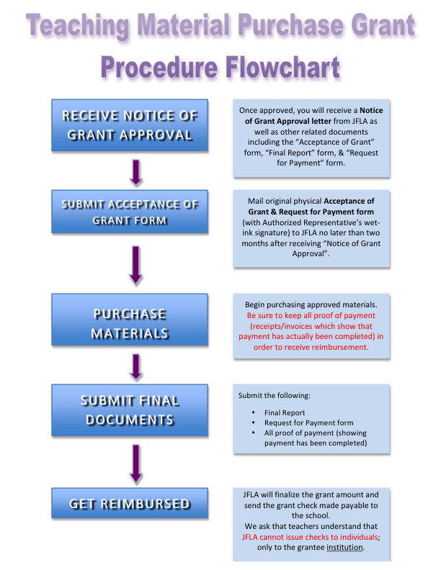

**Obligations of Grantees**

1. Programs of the Japan Foundation are operated in accordance with its own regulations as well as the relevant laws and regulations including “Law for the Proper Execution of a Budget Relating to Subsidies” (Law No. 179 of 1955)
2. Please acknowledge the JFLA grant support in any distributed publications and/or promotional materials.
3. Applicants must submit (1) “Final Report”, (2) proof of payment (receipts, invoices, etc. which show that payment has been completed), and (3) “Request for Payment” form in order to receive the grant payment.

**Disclosure of Information**

1. Details of projects supported by the Japan Foundation (e.g., the name of the applicant and project descriptions only; the grant amount will not be made public) will be made public in the *Kokusai* *Kōryū Kikin Jigyō Jisseki* (Detailed Annual Report of the Japan Foundation), on the Japan Foundation's website, and in other public-relations materials.
2. When a request for information based on the "Law Concerning the Disclosure of Information Held by an Independent Administrative Institution, Etc." (Law No. 140 of 2001), is received, materials such as submitted application forms will be disclosed (unless stipulated by laws as not to be disclosed).

**Handling of Personal Information**

1. The Japan Foundation handles personal information appropriately and in accordance with the "Law Concerning Access to Personal Information Held by Independent Administrative Institutions" (Law No. 59 of 2003). Details of the Japan Foundation's personal information protection policy can be reviewed at: <http://www.jpf.go.jp/e/privacy>
2. The Japan Foundation uses personal information on the application materials for screening, implementation, and evaluation procedures of the project. It may also be used for the following purposes:
3. Details of the successful applicants, such as names, gender, job and position, affiliation, project duration, and project description, are published in the *Kokusai Kōryū Kikin Jigyō Jisseki* (Detailed Annual Report of the Japan Foundation), the Annual Report, on the Japan Foundation's website, in other public-relations materials. They are also used in compiling statistics and released to the press for publicity purposes.
4. There may be cases in which these details are released to Ministry of Foreign Affairs of Japan, or the Embassies or Consulates-General of Japan at the place where a project is undertaken.
5. There may also be cases in which copies of applications, including documents containing some personal information, are provided to outside consultants in order to facilitate the screening process and the evaluation of the results of projects. The Japan Foundation requests the consultants to take measures to ensure the safety of the provided personal information.
6. There may also be cases in which the Japan Foundation sends questionnaires to the addresses written on this form after the project has ended.
7. There may also be cases in which the Japan Foundation uses the information written on the application form to contact the applicants to inform them of other Japan Foundation activities.
8. Applicants are requested to inform all individuals whose personal information appears on the application materials of the above-mentioned policy.
9. There may be cases in which the project reports and other related publications are released to the public.

Contact

Please feel free to contact The Japan Foundation, Los Angeles if you have any questions.

**The Japan Foundation, Los Angeles**

Jared McClellan, Japanese Language Associate Program Coordinator

5700 Wilshire Blvd. #100, Los Angeles, CA 90036

Tel: 1-323-761-7510, ext. 112

Email: [jared_mcclellan@jpf.go.jp](mailto:jared_mcclellan@jpf.go.jp) URL: www.jflalc.org