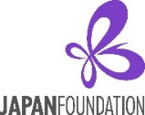
Fiscal Year 2024-25
Japanese-Language Education Project Grant (Sakura Network)
Application Instructions
Program Description
The Japan Foundation, Los Angeles (hereafter “JFLA”) provides financial assistance to the “JF Nihongo Network” (AKA: Sakura Network) member institutions/organizations for their nationwide or statewide projects which can benefit as many Japanese language programs and teachers as possible in a wide region. Therefore, projects which only benefit a single institution are not eligible for this grant program. If your project is designed to benefit Japanese language learners, please apply for our “Japanese Language Learners Event Grant.”
Grant Amount: Up to $10,000 per project
Eligible Projects for Support
Your proposed project should benefit or promote multiple Japanese language programs and teachers in a wide area (nationwide, statewide, or region-wide). The projects cannot be implemented for commercial, political, or religious purposes.
The project must start and finish between April 1, 2024 and March 31, 2025.
Type A: Workshops/Seminars/Conferences for Japanese language teachers
Priority will be given to workshops/seminars/conferences which can provide participants with professional development credits/units (university credits, continuing education units, professional development clock-hours, etc.) or certificates of attendance (proof of workshop participation), which can be used towards receiving/renewing teacher’s license/credential.
JFLA also encourages workshops/seminars/conferences which invite guest speakers not only from Japanese language education but also from the field of Japan Studies (Japanese Literature, History, Social Studies, etc.) so that Japanese language teachers can learn about Japan-related topics as well as how to incorporate the information pedagogically into their Japanese language classroom (content-based learning, project-based learning, etc.).
Type B: Other Original Projects
Any nationwide/statewide/region-wide projects which can benefit multiple Japanese language programs are welcome, however JFLA encourages the following types of projects.
- Projects which can bridge or integrate Japanese language education and Japan Studies.
- Advocacy projects to increase the visibility of Japanese language education in a wide region.
- Articulation projects for improving vertical articulation between different educational levels as well as horizontal articulation within the same educational level, in order to optimize students’ learning environment at multiple Japanese programs in a wide region.
- Survey/Research projects that will be conducted in order to grasp/analyze the current condition of Japanese-language education or to gather demographic information related to Japanese-language education.
- Teaching Material Development projects that will benefit educators/learners nationwide or in a wide region.

Grant Coverage
Type A: (1) Expenses for inviting guest lecturers (honorarium, accommodation, travel expenses)
(2) Venue expenses (venue rental, equipment rental, etc.)
(3) Production costs for handouts/flyers/proceedings
(4) Participants’ professional development credit application fees (university credits, CEU, etc.).
Type B: The eligible items for support will vary depending on the type of project.
Please consult with JFLA about what kinds of items for which you will need financial support.
Administrative costs related to your grant project may be requested as indirect costs, though they may not exceed 10% of
the direct costs requested.

NOTE: The following expenses are NOT eligible for support:
- Indirect costs (administrative costs) not related to the grant project,
- Expenses for any food or drinks,
- Office supplies, PC, copy machine, any other electric appliances, furniture such as desks, chairs, etc.,
- Regular operating costs of the Japanese-language courses and salaries of current teaching staff,
- Business meetings (general meetings, board meetings, etc.) that are held regularly by the applicants,
- Cost of buying real estate and cost of construction work,
- Rental fee for halls owned by the applying organization/institution or group,
- Banquet costs and entertainment costs,
- Airfare exceeding the estimated fare for the shortest route from the city of origin to the destination flying economy class.

Eligible Applicants
- Applicants must be non-profit educational institutions/organizations as well as “Sakura Network” member institution/organization in the U.S. (Individuals are not eligible to apply.)

- In principle, JFLA does not provide grants for:
    - The U.S. government, including their administrative organs such as ministries and their embassies; excluding academic, cultural, or research institutes such as universities and museums

    - Institutions/organizations to which the Japanese government currently makes a financial contribution

    - Institutions/organizations whose laws restrict them from receiving aid from foreign organizations affiliated with governments

    - Institutions/organizations which serve commercial, political, or religious purposes

- Applicants must have a bank account in the name of the institution/organization which is capable of accepting grants from JFLA, or should be able to open such accounts by the time the grants are sent. Receipt of grants or benefits from JFLA must not violate any laws and ordinances, etc.
Screening Criteria Applications will be reviewed from the following perspectives:
- Specific project outcomes expected
- Ripple effects of the project (benefits to Japanese language education in the national/regional level)
- Scale of the project (number of beneficiaries, number of schools involved, etc.)
- Topics/themes of the project
- Dissemination of project outcomes
- Ability to raise funds from sources other than the JFLA grant, including own funds
- Feasibility of the project plan (outline, framework, schedule, financial preparation, etc.)

Application Procedures
Before applying, please be sure to inform JFLA (mike_penny@jpf.go.jp) of your intention to apply for the grant.
Application Deadline: Two months prior to the start date of the project.

Please submit your Application Form to the Japan Foundation, Los Angeles by mail or Email (mike_penny@jpf.go.jp).
Application Form (Page 1) needs either a handwritten or electronic signature from the Authorized Representative of the applying institution/organization.
Mailing Address: The Japan Foundation, Los Angeles
Japanese Language Grant Dept.
5700 Wilshire Blvd., #100, Los Angeles, CA 90036

Post Application Procedures
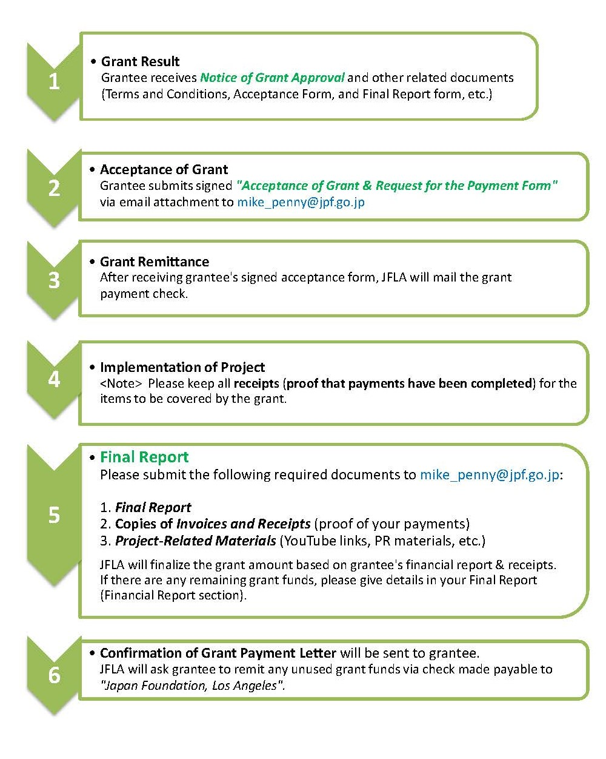
Grant Result:
Within 1 month
after JFLA receives the Application Form
(Acceptance Form)
Due: Within 2 months
of receiving the “Notice of Grant Approval”
Grant Payment:
Within 2-3 weeks after JFLA receives the Acceptance From
(Final Report)
Due: Within 2 months
after finishing the project
If there is any remaining grant funds,
the refund check is due within 30 days.
Obligations of Grantees
1. Programs of the Japan Foundation are operated in accordance with its own regulations as well as the relevant Japanese laws and regulations including "Law for the Proper Execution of a Budget Relating to Subsidies" (Law No. 179 of 1955)
2. Please acknowledge the Japan Foundation’s grant support in publications and/or promotional materials distributed by the grantees, if any.
3. The grantees shall submit the following documents upon finishing the grant project:
(a) “Final Report” with an original-ink handwritten signature.
(b) Proof of disbursements (receipt copies) for the expenses that the JFLA grant has provided.

Disclosure of Information
1. Details of projects supported by the Japan Foundation (e.g., the name of the applicant and project descriptions) will be made public in the Kokusai Kōryū Kikin Jigyō Jisseki (Detailed Annual Report of the Japan Foundation), on the Japan Foundation's website, and in other public-relations materials.

2. When a request for information based on the "Law Concerning the Disclosure of Information Held by an Independent Administrative Institution, Etc." (Law No. 140 of 2001), is received, materials such as submitted application forms will be disclosed (unless stipulated by laws as not to be disclosed).

Handling of Personal Information
1. The Japan Foundation handles personal information appropriately and in accordance with the "Law Concerning Access to Personal Information Held by Independent Administrative Institutions" (Law No. 59 of 2003). Details of the Japan Foundation's personal information protection policy can be reviewed at: http://www.jpf.go.jp/e/privacy
2. The Japan Foundation uses personal information on the application materials for screening, implementation, and evaluation procedures of the project. It may also be used for the following purposes:
- Details of the successful applicants, such as names, gender, job and position, affiliation, project duration, and project description, are published in the Kokusai Kōryū Kikin Jigyō Jisseki (Detailed Annual Report of the Japan Foundation), the Annual Report, on the Japan Foundation's website, in other public-relations materials. They are also used in compiling statistics and released to the press for publicity purposes.
- There may be cases in which these details are released to Ministry of Foreign Affairs of Japan, or the Embassies or Consulates-General of Japan at the place where a project is undertaken.
- There may also be cases in which copies of applications, including documents containing some personal information, are provided to outside consultants in order to facilitate the screening process and the evaluation of the results of projects. The Japan Foundation requests the consultants to take measures to ensure the safety of the provided personal information.
- There may also be cases in which the Japan Foundation sends questionnaires to the addresses written on this form after the project has ended.
- There may also be cases in which the Japan Foundation uses the information written on the application form to contact the applicants to inform them of other Japan Foundation activities.
3. Applicants are requested to inform all individuals whose personal information appears on the application materials of the above-mentioned policy.
4. There may be cases in which the project reports and other related publications are released to the public.

Contact
Please feel free to contact The Japan Foundation, Los Angeles if you have any questions.

The Japan Foundation, Los Angeles
Mike Penny, Program Officer
5700 Wilshire Blvd., Suite #100, Los Angeles, CA 90036
Tel: 323-761-7510 Email: mike_penny@jpf.go.jp URL: www.jflalc.org

