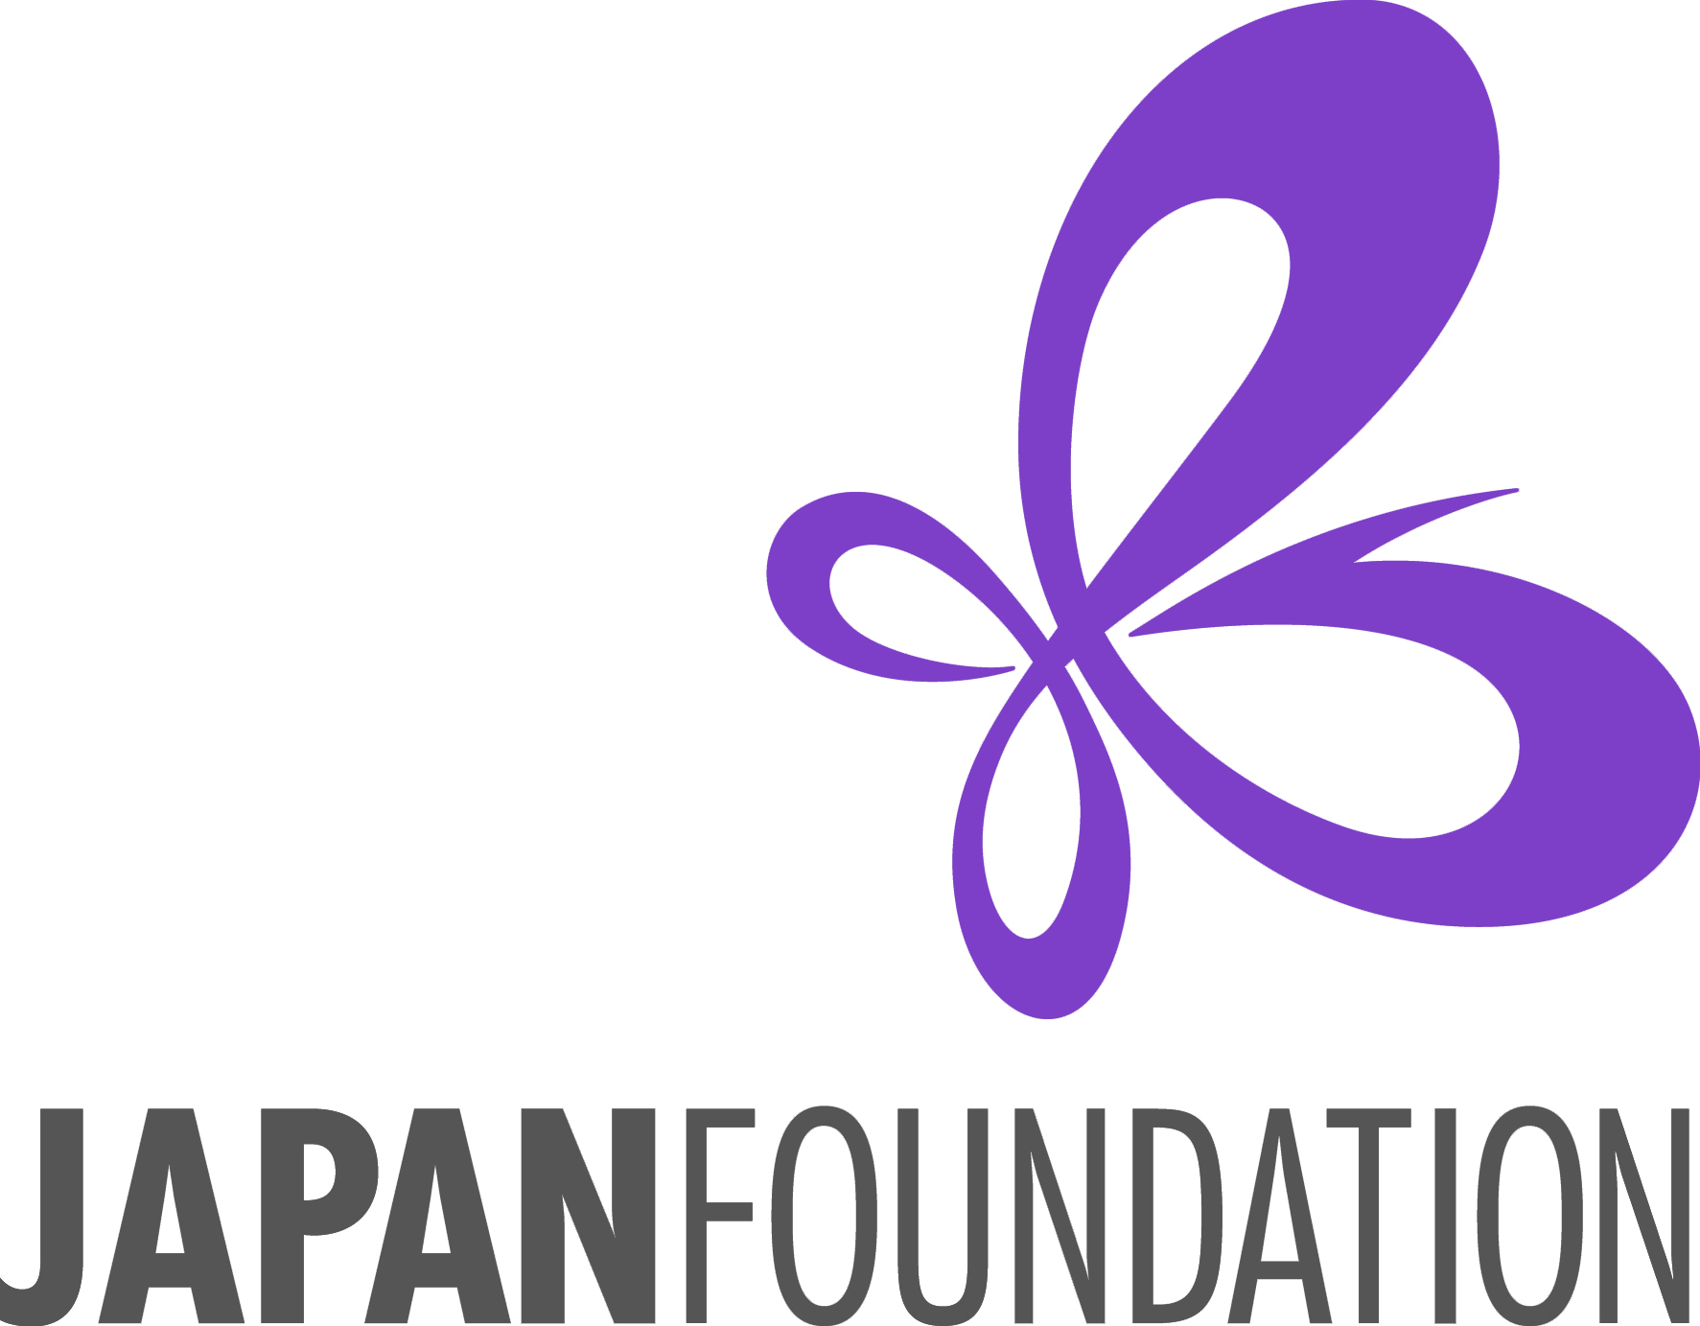
Application Form
NO LATE APPLICATIONS WILL BE ACCEPTED AT THIS TIME

Japanese Teaching Materials Purchase Grant

Fiscal Year 2026-27

Name of  Applying Institution | Public schools, please include the name of the school district. (Example: ○○School District ●●High School)
Dept./Section
in charge of
the proposed project
Address | <Japanese Language Program> |  | <Administrative Office> (if you have different address)
Legal Status | Non-profit Public Educational Institution  Non-profit Private Educational Institution  Other Non-profit Organization |  | Educational Level | Primary-school Education  Secondary Education  Higher Education  Other（ ）
Status of  Japanese Program | Please check all that apply. |  |  | Duration of  Japanese Program | Started this year  Less than 5 years ago  5-10 years ago  10-15 years ago  15-20 years ago  More than 20 years ago
Status of  Japanese Program | <Pre-Collegiate Level>  Compulsory  Compulsory Elective  Not-Compulsory Elective  Extra-curricular Afterschool  Others（ ） | <Collegiate Level>  Major (degree in B.A., etc.)  Minor  Compulsory Course (accredited)  Optional Course (accredited)  Others（ ） |  | Duration of  Japanese Program

 | Authorized Representative  President, Executive Director, Dean, Dept. Chair, District Superintendent, etc. | Project Director (Contact Person)  Person in charge of Japanese language program | Financial Director  Person who will handle the grant  payment check
Name | Prof. Dr. Mr. Ms. | Prof. Dr. Mr. Ms. | Prof. Dr. Mr. Ms.
Position
Email
Tel (Ext.#)

Signature  (Authorized Representative) |  | Date:

Timing of Grant Payment (PLEASE READ CAREFULLY)
We understand the following:

We may not begin purchasing materials listed on our wish list until we have received the official Notice of Grant Approval and have submitted our Acceptance of Grant form.

If awarded this grant, the payment check will not be provided until we have submitted proof of payment
(all receipts/invoices which show that payment has been completed) as well as all other required documents (Final Report, Request for Payment Form).

The grant payment check will be made payable to our institution, not to an individual.
(If we need to ask our Japanese language teacher to purchase items on behalf of our institution, we will reimburse him/her for the expense after we receive the grant payment check from the Japan Foundation.)

Reason(s) for Application

Outline of Japanese-Language Program
- Please describe your Japanese program (brief history, size, role in the community; Ex: “only Japanese program in the area”)

(2) Current Japanese-Language Courses
 | Course Title | Course Status  Compulsory,  Elective,  Extra-Curricular | Instructors |  | Hours of Instruction  per week  ( hours/day x days) | Number of Students
 | Course Title | Course Status  Compulsory,  Elective,  Extra-Curricular | Name | Title/  Position  Full-time, Part-time | Hours of Instruction  per week  ( hours/day x days) | Number of Students
Beginner
Level
Intermediate
Level
Advanced
Level
Total Number:

- Student Enrollment Numbers
(Have there been any recent changes/trends? What are your expectations for the enrollment in the coming years?)

(4) What kinds of ADVOCACY efforts do you do to promote your Japanese program in and out of the campus to increase
the student enrollment?

(5) Connection with other educational institutions, if any. (Exchange program with schools in Japan, etc.)

