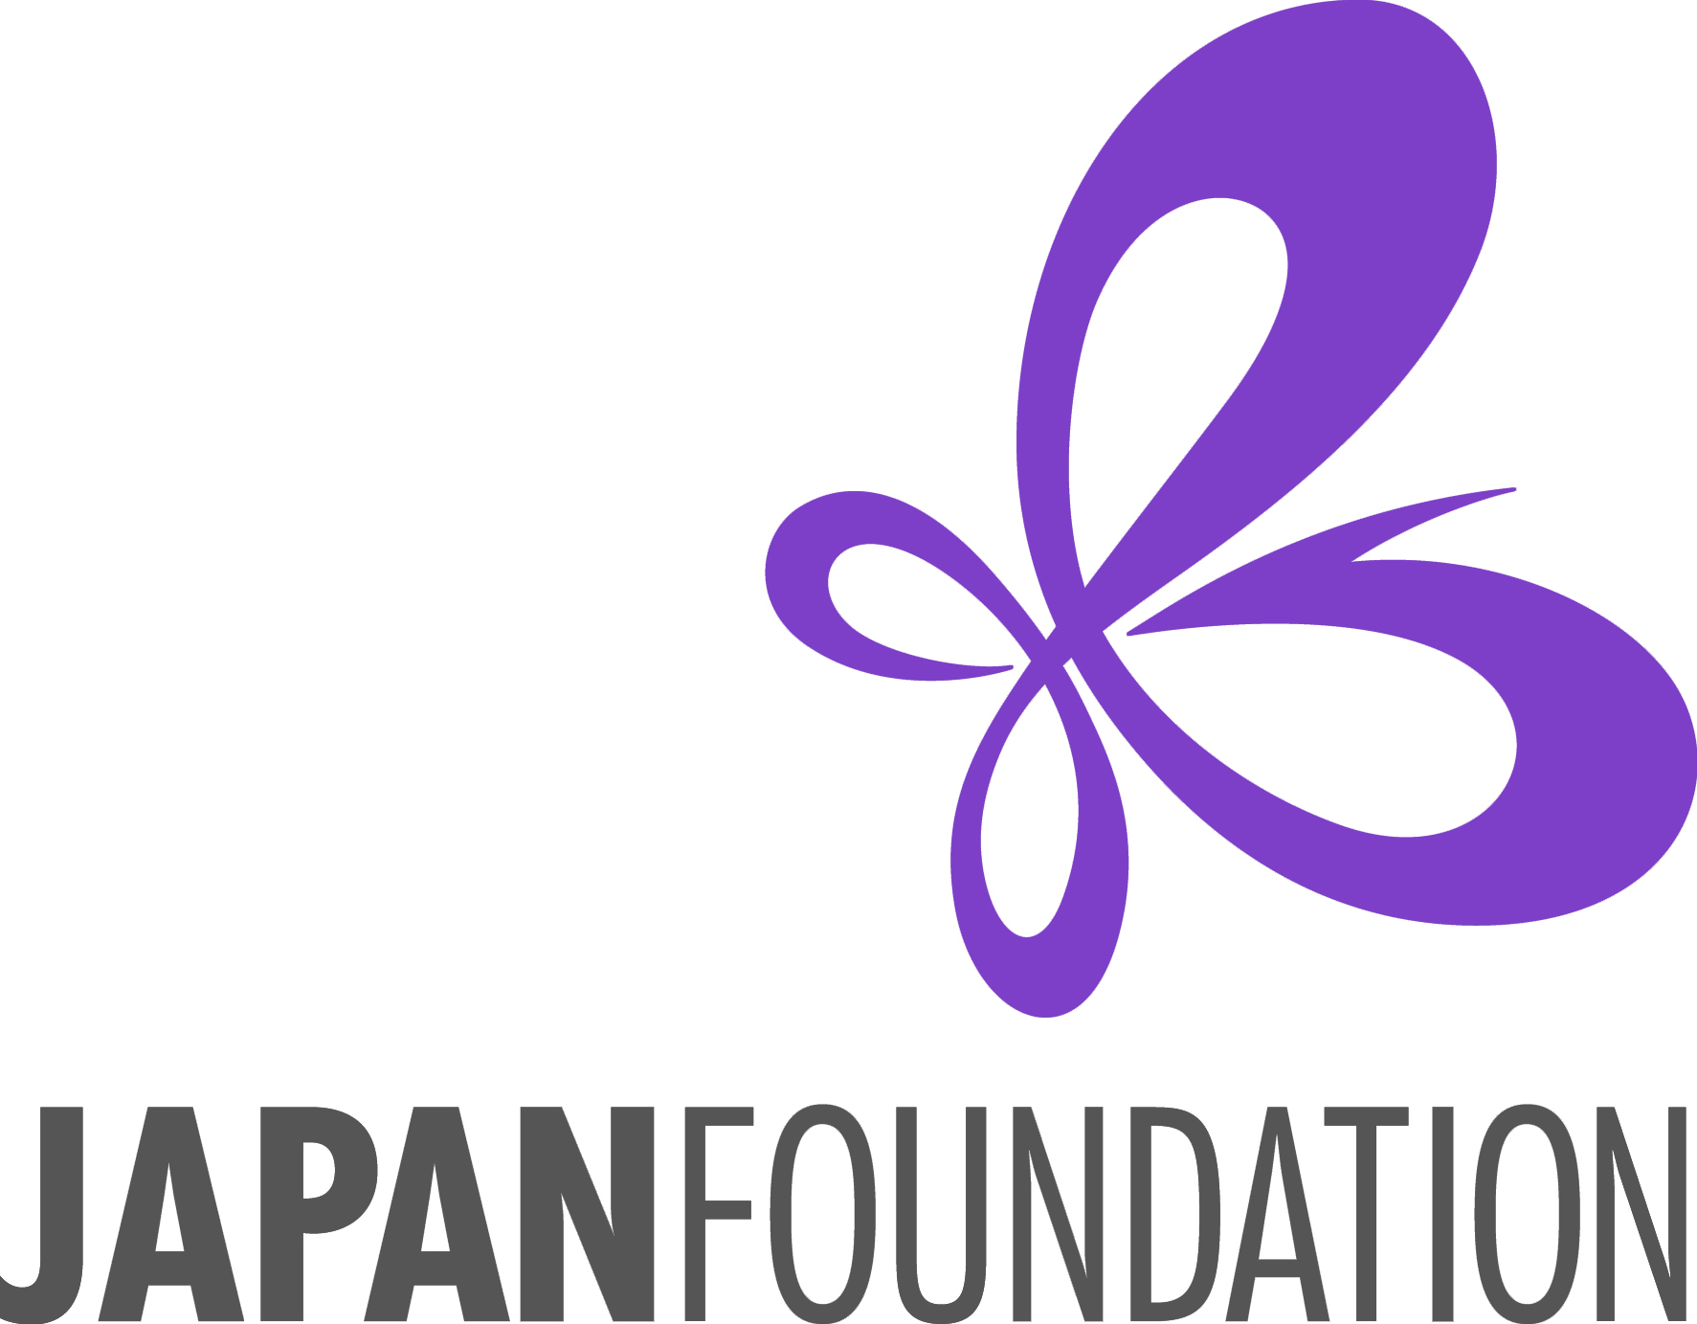
Fiscal Year 2017-18

Japanese Language Learners Event Grant

Application Instructions
Program Description
This program provides financial support for Japanese-language related events on the national/state/regional levels (speech contests, quiz contests, or presentational events, etc.) that are intended to motivate a large number of Japanese-language learners in multiple schools featuring different educational levels (primary, secondary, collegiate level, and adults) and promote Japanese-language education in the area. Closed events for a single school are not eligible.

Conditions of Grant
- The proposed events must be implemented between April 1, 2017 and March 31, 2018.
- Grant support is limited and will be up to $1,000. We expect the applying institutions/organizations to have a plan
on how to supplement the JF grant with other funding sources at the time of application.

- The following items are eligible for support:
- Expenses for inviting judges/guests to the event (honoraria, transportation, accommodation),
- Expenses for venue (rental fee for venue and equipment, service fee for tech support, etc.),
- Prize expenses for participating Japanese-language learners (no cash prizes),
- Production costs for handouts/programs/flyers of the event.
- Group transportation costs for participants/student audiences (charter buses, vans, etc.)

- The following elements are NOT eligible for support:
- Any costs for foods or drinks,
- Costs for holding a reception/banquet,
- Rental fee for halls owned by the applying institution/organization or group,
- Indirect costs that are not directly needed to carry out the applied project,
- Any administrative costs of the managing division (staff salary, office supplies, etc.),
- Costs for holding general meetings and board meetings that are held regularly by the applicant.

Eligibility
- Applications are only accepted from non-profit educational institutions/organizations involved in Japanese-language education. However, organizations whose laws restrict them from receiving aid from foreign organizations affiliated with governments are not eligible.

- In principle, the Japan Foundation does not provide grants for:
  - The U.S. government, including their administrative organs such as ministries and their embassies and consulates-general in Japan; excluding academic, cultural, or research institutes such as universities and museums; and
  - International organizations to which the Japanese government makes a financial contribution.

- Receipt of grants or benefits from the Japan Foundation must not violate any laws or ordinances, etc. (please confirm this before applying).

- Applicants must have a bank account in the institution’s/organization’s name capable of accepting grants from the Japan Foundation. A bank account may also be opened before receiving the grant payment.

- Applicants must have the necessary capabilities to implement their planned projects.

Requirements of the Proposed Events
- Projects must be implemented during the Japan Foundation’s Fiscal Year 2017-18 (April 1, 2017 – March 31, 2018).
- The plan and method of implementation must be appropriate and there must be ample expectations that the program will yield positive results.
- Projects must not be used for religious or political purposes.
- Projects must not be commercial activities.

Obligations
- The Japan Foundation’s grant programs are operated in accordance with relevant laws and regulations of the Japan Foundation.

- Please indicate the Japan Foundation as a supporter in any publications and/or promotional materials distributed by the grant recipients, if any.

- Grant recipients must submit required documents: (1) “Acceptance of Grant & Request for Payment” form, (2) “Final Report” form, and (3) “Questionnaire” form by their respective due dates.

Selection Method
Applications will be selected based on the following criteria:

- Role/influence of the applying institutions/organizations in the region
- Specific benefits to the Japanese-language learners in the region by the implementation of the project
- Specific result/effect on the Japanese-language education in the region by the success of the project
- Scale of project and the number of contestants and participating schools
- Necessity of financial support from JF (Financial status, potential to raise funds from sources other than the Japan Foundation, including its own funds, etc.)
- Previous grant history

Application Procedures and Deadlines
- Before applying, please be sure to inform the Japan Foundation, Los Angeles (hereafter “JFLA”) of your intention to apply for the grant. (Email: support@jflalc.org) If you do not contact JFLA in advance, your application may be rejected.

- Complete application form with handwritten signature from your Authorized Representative must be submitted to the JFLA office on or before the deadline. Please submit your application form either by mail or email with the scanned copy as an attachment.
(Email: support@jflalc.org)

[ Application Deadlines ]
- 1st Deadline: March 1, 2017 (for events to be held between 4/1/2017 and 3/31/2018)
- 2nd Deadline: September 1, 2017 (for events to be held AFTER 11/1/2017 and before 3/31/2018)
When the deadline falls on a weekend, it will be extended to the following Monday.
[ Mailing Address ] The Japan Foundation, Los Angeles
Attn: Mike Penny
5700 Wilshire Blvd. #100, Los Angeles, CA 90036

Disclosure of Information
1. Information on supported projects such as the name of the applicant and project descriptions will be made public on Kokusai Koryu Kikin Jigyo Jisseki (Detailed Annual Reports of the Japan Foundation Activities), the Annual Report, on the Japan Foundation’s website, and other public relations materials.
2. When we receive a request for information based on the “Law Concerning the Disclosure of Information Held by Independent Administrative Institutions, etc.” (Law No. 140 of 2001), as a general rule, submitted application forms and related materials will be disclosed, except for information stipulated in the law as something not to be disclosed.

Access to Personal Information
The Japan Foundation collects, uses and manages personal information appropriately in accordance with the Law Concerning Access to Personal Information Held by Independent Administrative Institutions (Law No. 59 of 2003). Applying organizations and groups should inform those they intend to invite to participate (hereafter, “participants”) of these uses of personal information.

・The Japan Foundation uses information such as the names of the accepted party and the participants, gender, job and position, affiliation, project duration, and project description in the Kokusai Koryu Kikin Jigyo Jisseki (Detailed Annual Reports of the Japan Foundation Activities), the Annual Report, on the Japan Foundation’s website, and in other public-relations materials. This information is also used to prepare statistical materials included in the Annual Report.

・The Japan Foundation may provide information such as the names of the accepted party and the participants, gender, job and position, affiliation, project duration, and project description to the media and other groups for publicity purposes.

・There may be cases in which the Japan Foundation uses the information given on the application form to contact you to inform you of other Japan Foundation activities (such as requests for other projects) or to send information on the Japan Foundation.

・The application, attached materials and project report and deliverables may be provided to evaluators, such as outside experts, for screening and post-evaluations. When such information is provided, the evaluator will take steps to ensure the safety and confidentiality of personal information.

・There may be cases in which the Japan Foundation sends questionnaires to the addresses given on the application form after the project has ended.

・The Japan Foundation may release the project reports and deliverables that it has received for public relations purposes.

・The applications and attached materials submitted to the Japan Foundation are not returned.

Contact
Please feel free to contact JFLA if you have any questions.

The Japan Foundation, Los Angeles
Mike Penny, Associate Program Officer
5700 Wilshire Blvd. #100, Los Angeles, CA 90036
Tel: 1-323-761-7510, ext. 116 Fax: 1-323-761-7517
Email: support@jflalc.org URL: www.jflalc.org

