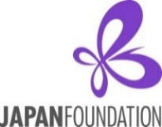

Fiscal Year 2026-27
Salary Assistance Grant for Japanese-Language Courses
Application Instructions

Program Description
The Japan Foundation, Los Angeles (hereafter “JFLA”) supports non-profit educational institutions or school districts in the U.S. that are facing temporary financial difficulties in the following three cases. The grant covers a part of the Japanese language instructor’s salary and fringe benefits up to $30,000 on a cost-sharing basis.

Case (1): Starting up a brand new Japanese program
Case (2): Expanding a current existing Japanese program by adding new course(s)/section(s)
Case (3): Maintaining a current existing program which is in danger of cut back or closure

The grant support is given on the condition that the applying institutions (hereafter “Applicants”) will continue to offer the Japanese language program after the grant support ends. It is required that applicants submit at least one commitment letter or strong support letter from the stakeholders (e.g., Dean, Dept. Chair, District Superintendent, Head of the Board of Education, Principal, or local business supporters, etc.) at the time of their application regarding the continuation of Japanese program on a long-term basis after the grant support ends and beyond. Applications without these letters may also be considered depending on the situation.

＊＊＊＊＊＊＊＊＊＊＊＊＊＊＊＊＊＊＊＊＊＊＊＊＊＊＊＊＊＊＊＊＊＊＊＊＊＊＊＊＊＊＊＊＊＊＊＊＊＊＊＊＊＊＊＊＊＊＊＊＊＊＊＊
Case (1) STARTING UP a brand new Japanese program:
Applicants can request funding for up to TWO years at the time of application; however, due to our single-year budget system, JFLA can only decide the grant award year by year, and the continuation of the grant support for Year 2 (Academic Year 2027-28) is not automatic. The applicants who have successfully received the Year 1 grant support will need to submit a “Budget Proposal (Year 2)” in mid-March along with their “Interim Report (Year 1).” Then, JFLA will decide on the Year 2 grant after carefully reviewing these documents.

Case (2) EXPANDING or Case (3) MAINTAINING a current existing Japanese program:
Applicants can request funding for ONE year(*). The grant is given on the premise that the Japanese language program and the instructor(s)’ position(s) at the institution will be maintained after the completion of the one-year grant support.

(*) Applicants may apply again for the second following year (Academic Year 2027-28) after receiving one year grant support; however, they will be given lower priority than first-time applicants who have never received the JFLA grant support in the past.

Conditions of Grant
- The grant support is given on the condition that the applicant will continue to offer the Japanese program after the grant support is over and beyond. Each applicant must submit a detailed plan on how they will maintain the Japanese program beyond the grant period.

- The grant only covers the Japanese language instructor(s)’ salary and fringe benefits.
Any other overhead costs (for example, costs related to housing, commuting, administrative labor, etc.) are NOT covered by this grant.

- The grant can be used for either full-time or part-time instructors, NOT for teaching assistants (TA).
If the applicant has already decided on the instructor(s) by the time of application, the instructor(s)’
information (bio, resume, or curriculum vitae) and a copy of employment agreement should be attached
to the application form.

- Applicants can request up to $30,000 per year. (The salary schedule should be attached to the application form.) The grant amount will be determined in accordance with JFLA’s assessment scale, and it may be less than the amount requested.

- The grant can be used for several instructors at the same school/institution, but the grant amount will NOT exceed more than $30,000 per institution/school.

- In the event that a school district applies for this grant on behalf of several schools in the same district,

- The school district may request more than $30,000 for multiple schools at once. For example, one school district may request up to $60,000 in total for two schools (up to $30,000 per school).

- However this “up to $30,000 per school” applies only when the school district has more than one teacher at multiple schools in the same district. In other words, in the event that there is only one teacher in a district and he/she teaches at multiple schools in the same district, then they can only request up to $30,000.

- The grant is provided on a cost-sharing basis between the applicant and JFLA, meaning that the applicant is expected to have detailed plans on how they will supplement the JF grant with their own or other funds if they are approved for the grant. The preferable cost sharing from own funds is at least 1/3 (33%) of the total annual salary expense.

- The grant support is for one year. Due to the single-year budget system, JFLA can only decide on a grant award for one year at a time. However only in Case (1) Starting up a brand new program, applicants may request two-year grant support at once. The grant amount is decided year by year. The continuation of grant support for Year 2 is not automatic and will be decided after JFLA review the Year 1’s Interim Report as well as Final Report.

- In principle, the grant is for the Academic Year 2026-27. Applicants who have successfully received the grant need to start using the grant no later than late March, 2027. In other words, the “Start Date” of the grant period has to be before late March, 2027.

Eligible Applicants
- Applicants must be non-profit institutions/organizations involved in Japanese-language education in the U.S. (Individuals are not eligible to apply.)

- In principle, JFLA does not provide grants for:
    - The U.S. government, including their administrative organs such as ministries and their embassies; excluding academic, cultural, or research institutes such as universities and museums

    - Institutions/organizations to which the Japanese government currently makes a financial contribution

    - Institutions/organizations whose laws restrict them from receiving aid from foreign organizations affiliated with governments

    - Institutions/organizations which serve commercial, political, or religious purposes

- Applicants must have a bank account in the name of the institution/organization which is capable of accepting grants from JFLA, or should be able to open such accounts by the time the grants are sent. Receipt of grants or benefits from JFLA must not violate any laws and ordinances, etc. Failing to submit your signed Acceptance of Grant & Request for Payment form by the specified due date (within 2 months of notice of grant approval) could result in JFLA rescinding its grant.

Application Deadline: April 10, 2026
- Before applying, please be sure to inform JFLA (jflalanguage@jpf.go.jp) of your intention to apply for the grant. If you do not contact us in advance, your application may be rejected.

- Please submit the following required materials to JFLA (jflalanguage@jpf.go.jp) on or before April 10, 2026.

<Required Documents>

    - Application Form with either a handwritten or electronic signature from an authorized representative of the applying institution/organization.
    - At least one signed Commitment Letter (or Strong Support Letter) regarding the continuation of the Japanese language program on a long-term basis beyond the grant period.
    - Salary Schedule at the applying institution (Please indicate which salary range the instructor(s) who needs the JF grant support will fall under).
    - Instructor’s Information (Resume, Bio, or CV) only if you have already decided on the instructor(s).
    - Copy of Employment Agreement of the instructor(s) if already available.

Note: If you have not yet decided on the instructor(s), please submit ④ and ⑤ above later at your earliest convenience.

Post-Application Procedures
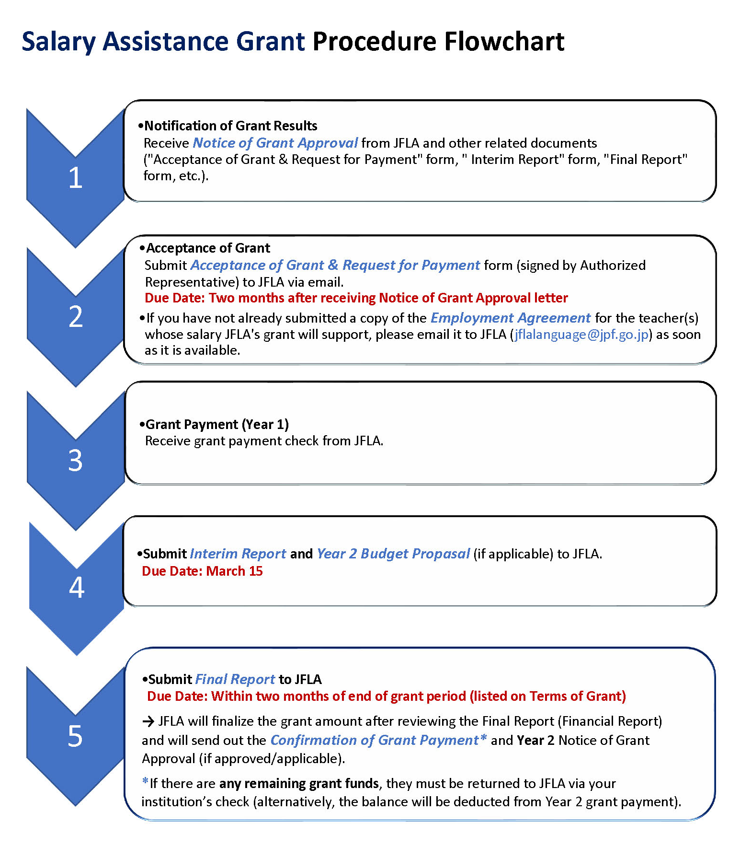

Grant Result
Late May/Early June, 2026

Acceptance Form
Due within 2 months
upon on receiving
the Approval Notice

Grant Payment
2-3 weeks after JFLA receives Acceptance of Grant & Request for Payment form

Interim Report
Due March 15, 2027(*)

Final Report
Due within 2 months
After grant period ends.

(*) In the case of STARTING UP a brand new program and requesting two-year grant, the applicant must submit
a “Budget Proposal (Year 2)” along with the “Interim Report (Year 1)” in mid-March, 2027.

Screening Criteria
Applications will be selected based on the following criteria:

- Strong commitment/support regarding the continuation of Japanese program (teachers’ positions and courses) on a long-term basis after the grant support is over and beyond
- Necessity of the grant support (level of financial need)
- Role of the applying institutions in the region (specific benefits to Japanese-language education in the region from the success of the proposed Japanese-language program)
- Specific advocacy plan for increasing the student enrollment
- Potential to raise other funds besides JFLA’s grant support, including its own funds
- Number of students
- Feasibility of the plan (program to be implemented, framework, schedule, etc.)

- Grant history (Applicants who have never received JF grant support in the past will take priority.)

Obligations of Grantees
- Programs of the Japan Foundation are operated in accordance with its own regulations as well as the relevant Japanese laws and regulations including "Law for the Proper Execution of a Budget Relating to Subsidies” (Law No. 179 of 1955)

- Please acknowledge the Japan Foundation’s grant support in publications and/or promotional materials distributed by the grantees, if any.

- The grantees shall submit the mid-year Interim Report as well as Final Report upon finishing the grant period.

- The Japan Foundation is intolerant of any fraudulent activity from the application process through the grant duration. Once a grant has been provided, committing any form of fraud with regard to the Japan Foundation grant funds could result in penalty measures such as revocation of decision to provide a grant in whole or in part, required return of rescinded portions of the grant including additional charges, late payment charges, suspension of the grant for a certain period of time, and/or other legal actions.

Disclosure of Information
- Details of projects supported by the Japan Foundation (e.g., the name of the applicant and project descriptions) will be made public in the Kokusai Kōryū Kikin Jigyō Jisseki (Detailed Annual Report of the Japan Foundation), on the Japan Foundation's website, and in other public-relations materials.

- When a request for information based on the "Law Concerning the Disclosure of Information Held by an Independent Administrative Institution, Etc." (Law No. 140 of 2001), is received, materials such as submitted application forms will be disclosed (unless stipulated by laws as not to be disclosed).
Handling of Personal Information
- The Japan Foundation handles personal information appropriately and in accordance with the "Law Concerning Access to Personal Information Held by Independent Administrative Institutions" (Law No. 59 of 2003). Details of the Japan Foundation's personal information protection policy can be reviewed at: http://www.jpf.go.jp/e/privacy

- The Japan Foundation uses personal information on the application materials for screening, implementation, and evaluation procedures of the project. It may also be used for the following purposes:

- Details of the successful applicants, such as names, gender, job and position, affiliation, project duration, and project description, are published in the Kokusai Kōryū Kikin Jigyō Jisseki (Detailed Annual Report of the Japan Foundation), the Annual Report, on the Japan Foundation's website, in other public-relations materials. They are also used in compiling statistics and released to the press for publicity purposes.

- There may be cases in which these details are released to Ministry of Foreign Affairs of Japan, or the Embassies or Consulates-General of Japan at the place where a project is undertaken.

- There may also be cases in which copies of applications, including documents containing some personal information, are provided to outside consultants in order to facilitate the screening process and the evaluation of the results of projects. The Japan Foundation requests the consultants to take measures to ensure the safety of the provided personal information.

- There may also be cases in which the Japan Foundation sends questionnaires to the addresses written on this form after the project has ended.

- There may also be cases in which the Japan Foundation uses the information written on the application form to contact the applicants to inform them of other Japan Foundation activities.

- Applicants are requested to inform all individuals whose personal information appears on the application materials of the above-mentioned policy.

- There may be cases in which the project reports and other related publications are released to the public.

_____________________________________________________________________________________________

Contact: Please feel free to contact The Japan Foundation, Los Angeles if you have any questions.

The Japan Foundation, Los Angeles
Mike Penny, Program Officer
5700 Wilshire Blvd. Suite #100, Los Angeles, CA 90036
Email: jflalanguage@jpf.go.jp
URL: www.jflalc.org

